Introduction to States

A representative sample of states was selected for analysis. The states are diversified amongst geographical region and impact of housing crisis measured by foreclosure rates and number of negative equity mortgages. The selected states for complete modeling and analysis are Alabama, Arizona, California, Florida, Georgia, Indiana, Kansas, Kentucky, Massachusetts, Michigan, Mississippi, Montana, North Dakota, New Jersey, New York, Ohio, South Dakota, Texas, Vermont, and West Virginia.

Of these twenty states, five states were … for complete … These states are Arizona, California, Florida, Texas, and Montana.

Explain negative equity definition.

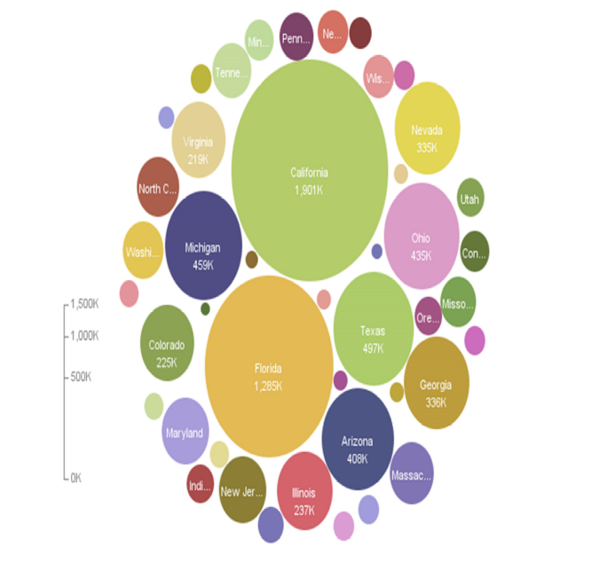

The national housing crisis has had varying effects on different states. Some states are experiencing high foreclosure rates, while others seemed to be unscathed by the adverse housing climate.

In Figure V.9, states are shaded with respect to their own foreclosure rates. In selecting the states for analysis, states different points on the foreclosure rate spectrum were chosen.

Thus, in the following selected states analysis, three were chosen from the high foreclosure rate states (Arizona, California, Florida), one from the mid-foreclosure rate states (Texas), and one with a low foreclosure rate (Montana).

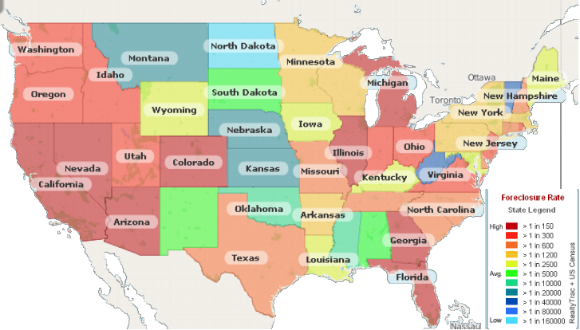
Figure V.1: States by foreclosure rate

